1. Lu Jing, Peiyun(Seed) Zeng
2. For Deque and Vector. They have random access iterator, so they can access any position at constant time (the iterator can directly get to certain position). For the iterator (list’s) does not support random access, we have to increment it step by step
3. To get empty range, pass in the same iterator for start and end. To get non-empty range, the second iterators should be at least 2 increments away

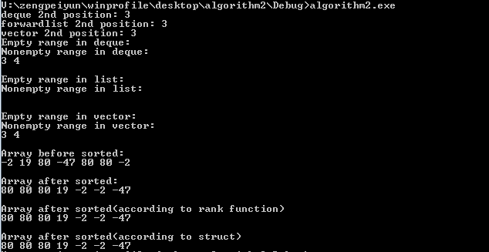

4-6

